**CN Project-II**

# Contributors:

1. **Jeevitha Mahankali (800966168)**
2. **Raghava Adarsh Mandarapu (800937296)**

**Go Back N :**

Go Back is an automatic repeat request protocol which the sender sends multiple frames without even receiving any acknowledgement. It uses sliding window protocol with sender window size N and receiver window size 1. Once the receiver receives the packet it sends ACK number back to sender and the number of that ACK is the sequence number of the next packet.

Lost Frame:

If a frame is lost the receiver sends a NAK response to the sender and the receiver discards all the frames after the lost packet and it again resends all the packets from where it is lost

Lost Ack:

If a sender doesn’t receive an ACK for a frame it waits until the time out period and resends all the packets from where the packet’s ACK is lost.

**Selective Repeat Protocol:**

The selective repeat protocol is a sliding window protocol which is similar to Go back n protocol with an equal sender and receiver window size of 2m -1. In this protocol it sends only the packet which is lost rather than sending all the packets from where the packets are lost or ACKs are lost.

Lost Frame:

If a frame is lost the receiver sends a NAK to the sender and sender retransmits only the frame which is lost rather than retransmitting all the frames from where it is lost.

Lost Ack :

If an ACK is lost the sender waits for a time out period and it retransmits the frame for which the ACK is lost.

**Instructions to Run the code:**

1. Open the Command prompt and navigate the path to the project folder

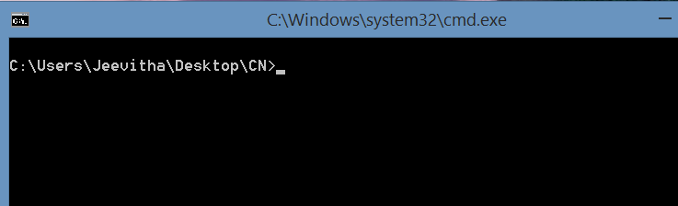

1. Compile the files present in the folder by using the command

“ javac *.java”

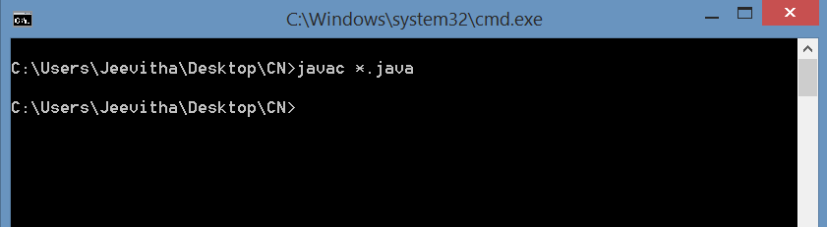

1. Start the server program by command “ java Server 8080” where 8080 is the port number

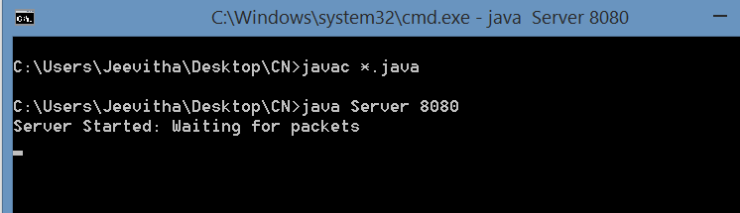

For **Go-Back-N** protocol:

1. Open another command prompt to run the Client program by typing the command

“java Client gbn.txt 8080 1000 “

Where “gbn.txt” file contains the required parameters for the go-back-n protocol

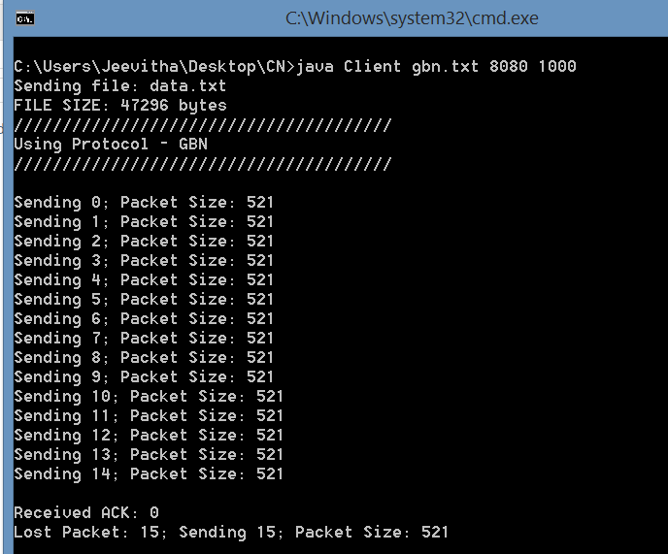

The corresponding action at Server Side:

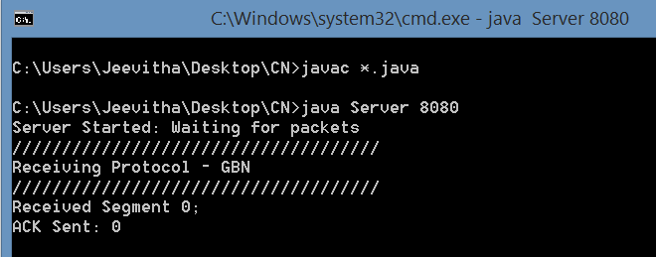

Once the Client has completed sending the contents of “data.txt” file present in the project folder, a new file named “output.txt” is generated which contains all the data that is transferred from the client to server.

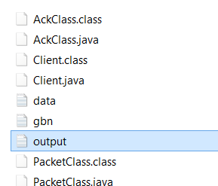

The Faulty network behaviors for Go-Back-N protocol such as Checksum error, lost packet error, lost ACK error are implemented in the code.

a) Checksum error implemented with probability of error as 0.1

At Server side: 11th packet has been discarded due to checksum mismatch

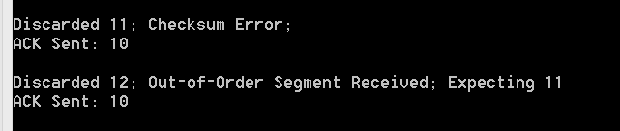

At Client side: packet 11 is sent

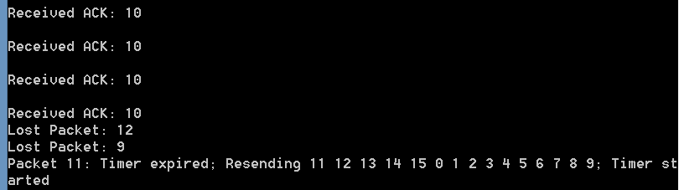

b) Lost Packet error implemented with probability of error as 0.1

At Server side:

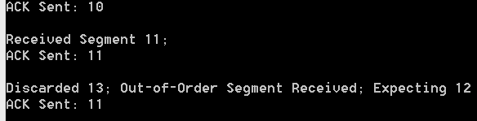

At Client side:

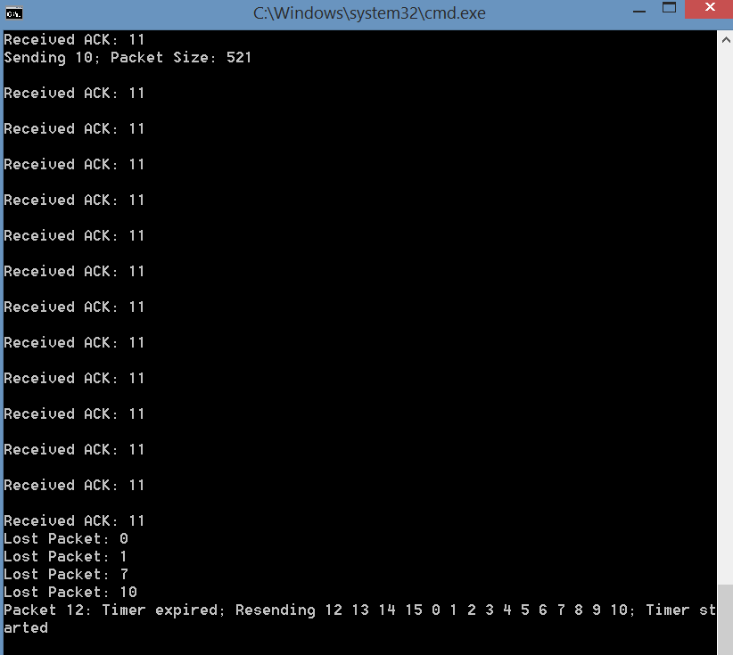

c) Lost Ack error implemented with probability of error as 0.05

At Server side:

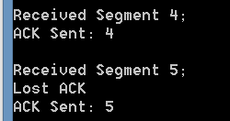

At Client side:

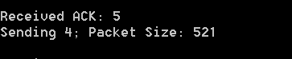

For **SELECTIVE REPEAT** protocol:

1. In the Command prompt used for Go-Back-N Protocol Client, now Input the Command

“java Client sr.txt 8080 1000 “

Where “sr.txt” file contains the required parameters for the Selective-Repeat protocol

\*\*\***Please start the server again to check the selective repeat protocol.**

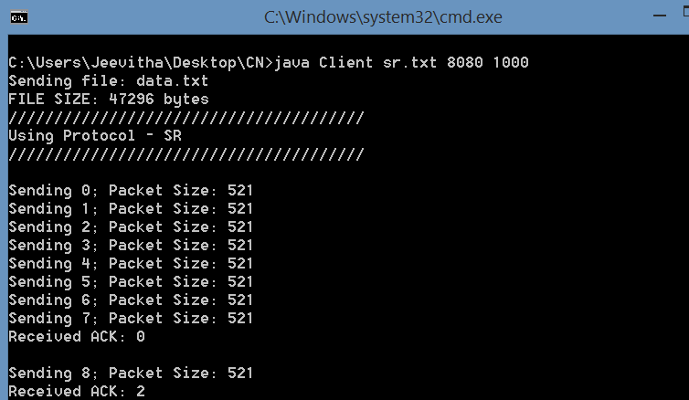

The corresponding action at the Server side:

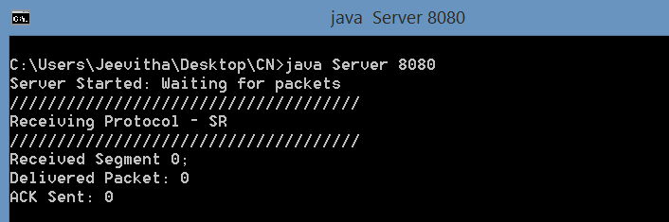

Once the transfer is completed, the “output.txt” file will be generated which contains the data sent from Client to server by using Selective Repeat Protocol.

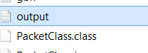

The Faulty network behaviors for Selective Repeat protocol such as Checksum error, lost packet error, lost ACK error are implemented in the code.

a) Checksum error implemented with probability of error as 0.1

At Server side: packet 5 is discarded and ack is not sent for 5th packet

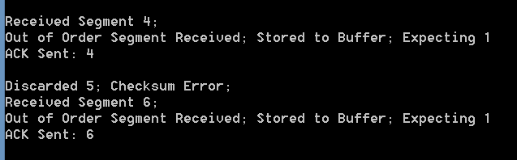

At Client side:

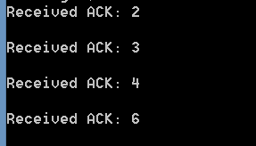

b) Lost Packet error implemented with probability of error as 0.1

At Server side: packets 12,13,14 are lost and 15th is received

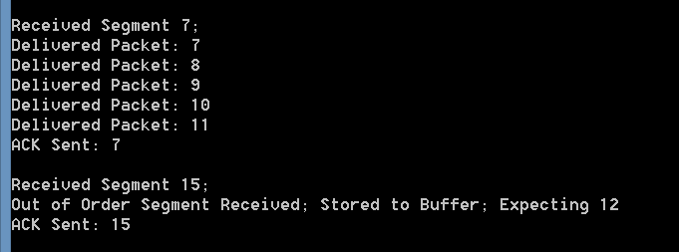

At Client side:

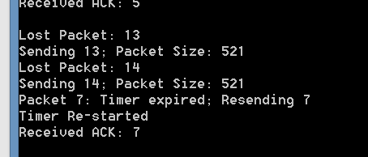

c) Lost Ack error implemented with probability of error as 0.05

At server side:

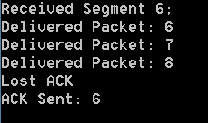

At client Side: the lost Ack 6 is received at client

